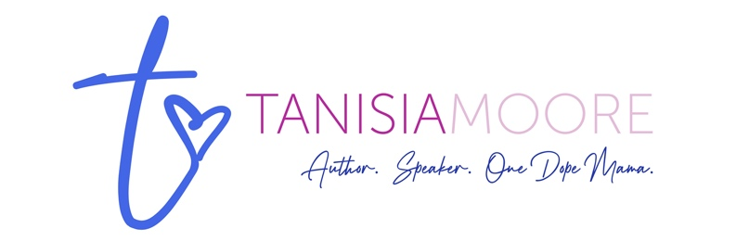

Short Biography:

Tanisia “Tee” Moore is a revered voice of African American storytelling known affectionately as “your family’s favorite author.” She writes for young people under her own name and in adult contemporary romance as Nisia Roye. The common thread in all her books is her deep love of sharing life lessons embedded in Black culture.

Tee’s current releases are picture book I Am My Ancestors’ Wildest Dreams with illustrator Robert Paul Jr and chapter book Micah Hudson: Football Fumble with illustrator Aaron Cargill. Tee’s next picture books will be When Black Girls Dream Big with illustrator with Robert Paul Jr (out October 15, 2024) and Wash Day Love with illustrator Raissa Figueroa in Spring 2025. With Lyn Miller-Lachmann, Tee is the author of the YA nonfiction book Film Makers: 15 Groundbreaking Women Directors. In adult contemporary romance, she penned After the Storm. Tee has new novels in the works.

Tee passionately believes that motherhood does not mean giving up womanhood. She hosts a podcast, The Other Side of Momming, and is the force behind MomTings.com, an apparel and lifestyle brand for mamas who need a gentle reminder that you can care for your babies and tend to your dreams.

Originally from Southern California, Tee is a proud alumna of Clark Atlanta University—where she majored in Mass Media Arts with a concentration in radio—and Florida A&M University College of Law. She is a former attorney now writing and momming full-time in Alabama.

For more on the many flavors of Tee, visit https://linktr.ee/moteellc

Long Biography:

Tanisia “Tee” Moore is a revered voice of African American storytelling known affectionately as “your family’s favorite author.” She writes for young people under her own name and in adult contemporary romance as Nisia Roye. The common thread in all her books is her deep love of sharing life lessons embedded in Black culture.

For young people, Tee is the author of:

- I Am My Ancestors’ Wildest Dreams (picture book with illustrator Robert Paul Jr, Scholastic Press)
- When Black Girls Dream Big (picture book with illustrator Robert Paul Jr, Scholastic Press, out October 15, 2024)
- Wash Day Love (picture book with illustrator Raissa Figueroa, Scholastic Press, out Spring 2025)
- The Micah Hudson chapter book series (Book 1, Micah Hudson: Football Fumble with illustrator Aaron Cargill, Reycraft Books),
- Film Makers: 15 Groundbreaking Women Directors (YA nonfiction with Lyn Miller-Lachmann, Chicago Review Press)

In adult contemporary romance, Tee is the author of After the Storm (writing as Nisia Skyy, Dynamic Image Publications). She has new novels in the works.

Tee passionately believes that motherhood does not mean giving up womanhood. On her podcast, The Other Side of Momming, Tee and her special guests spill the, ahem, *tea* on it all — finding joy, self-care, pregnancy, dating, divorce, grief, and (you know it!) sex. You can raise tiny humans and live out your purpose, all while being very dope. Tee is also the force behind MomTings.com, an apparel and lifestyle brand for mamas who need a gentle reminder that you can care for your babies and tend to your dreams. Some tings are just for you.

Originally from Southern California, Tee is a proud alumna of Clark Atlanta University—where she majored in Mass Media Arts with a concentration in radio—and Florida A&M University College of Law. She is a former attorney now writing and momming full-time in Alabama.

For more on the many flavors of Tee, visit https://linktr.ee/moteellc

